**IT-540 changes for 2022**

* Line 6D is renamed: Exemptions
  + Calculation stays the same
* New Line 6E- DEPENDENTS FOR CERTAIN ADOPTIONS DEDUCTION
* New Line 6F - TOTAL EXEMPTIONS
  + Subtract Line 6E from Line 6D.
  + This field is used to calculate tax.
* Line 8B is now: FEDERAL ITEMIZED DEDUCTION FOR MEDICAL AND DENTAL EXPENSES
* Line 8C is now: FEDERAL STANDARD DEDUCTION
  + was 2021 Line 8B
  + If filing status is 1 or 3, enter $12,950; 2 or 5, enter $25,900; 4, enter $19,400.
* New Line 8D is: EXCESS FEDERAL ITEMIZED DEDUCTIONS
  + was 2021 Line 8C
* 2021 Line 10 is now Line 9 and all rows below it has been renumbered accordingly.
  + 2021 Line 9 FEDERAL INCOME TAX was removed.
* Line 9- new tax rates.
  + See form R-6200 posted on team site for formula.
* Line 29 (2021 line 30) is renamed: AMOUNT OF EXTENSION PAYMENT

**Schedule C**

* Credit code 185 removed
* New code added:
  + Code 198 for Legal Settlement
    - This code is for internal use only. This code is not listed on the return and is not for public use.

**Schedule D**

* Removed Line 14 and renumbered remaining
* New Ones Added:
  + Line 19- Maddie's Footprints
    - Fee is retained
  + Line 20- University of New Orleans Foundation
    - Fee is retained
  + Line 21- Southeastern Louisiana University Foundation
    - Fee is retained

**Schedule E**

* Line 2C is now: RECAPTURE OF START K12 CONTRIBUTIONS
  + 2021 Line 2C was removed.
* Line 4H is renamed: Exempt Income
  + Calculation stays the same.
* Removed lines 4I through 5B
* 2021 Line 5C is renumbered as Line 5
  + Calculation is now subtract Line 4H from Line 3
* New codes added-
  + 25E - IRC 280C Expense Adjustment
    - This was reported on 2021 Line 5B.
  + 28E - START K12 Contributions
    - Needed to get with LSOFA
  + 29E Digital Nomads
    - Individuals & amounts will be preapproved, will need to be tracked in BCM
  + 30E Certain Adoptions
    - Will be receiving a list of some that qualifies from DCFS

**Schedule F**

* Removed Code 57F
* New codes added:
  + 76F Stillborn Child
  + 77F Funeral and Burial Expense for a Pregnancy-related Death

**Schedule H**

* deleted in whole

**Schedule J**

* Added new codes
  + 463 Apprenticeship (2022)
    - Has cap of $2.5million per calendar year; need to track in BCM
    - No preapproval of credit is being done.
  + 464 Donation to Qualified Foster Care Charitable Organization
    - Has cap of $500,000 per calendar year; need to track in BCM
    - No preapproval of credit is being done.
* Renamed code 236 to Apprenticeship (2007)

**Refundable Child Care Credit Worksheet**

* Calculation is returning to how it was for 2020.

**Other-**

* need to do more testing on all income tax returns due to rate changes, for both DELTA and software vendors.

**Posting tab**

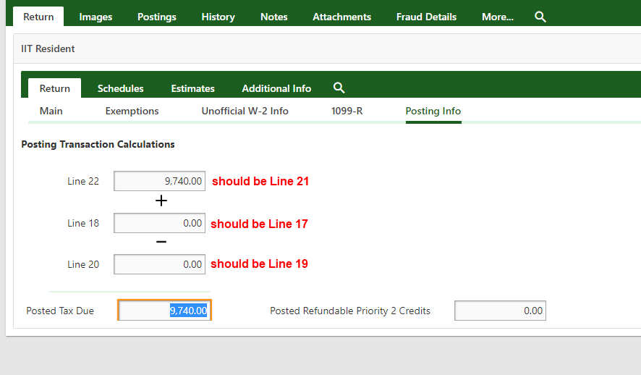

**1099-G calculation**

* “Not included refundable P2” group add:
  + Code 76F Stillborn Child
  + Code 77F Funeral and Burial Expense for a Pregnancy-related Death