Greetings all,

A slight change was made Doc ID# 22458/ Schedule J: Line 2b was updated to increase max characters from 5 to 6 and Line 2c was updated to increase max characters from 5 to 9.

**Screenshot from draft 5 of the specifications document**

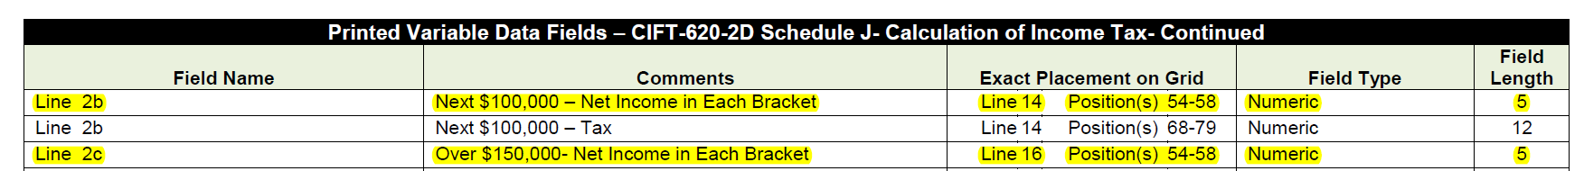

**Screenshot from draft 6 (posted to the FTA site 1.4.2024) of the specifications document**

