**2020 Scan Line Form Scenario Test Pack**

This test pack contains two data-filled scenarios per scan line form. When you generate your substitute documents for test submission, use the data in the test pack to populate two iterations of each form, then create the corresponding scan lines for each form.

This test pack should coincide with use of the “2020 Other Substitute Return Specifications” for scan line substitute document form development and test submissions.

*Note: In the scenarios listed below, you’ll see black boxes indicating areas of scan line placement. These boxes aren’t part of the forms. For exact specifications of scan line placement, please refer to “2020 Other Substitute Return Specifications”*

**ID-VP Income Tax Voucher Payment**

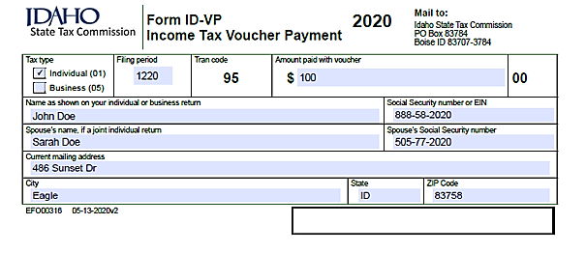

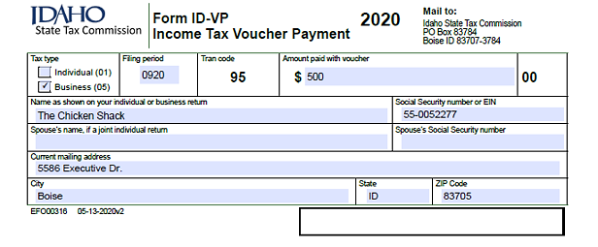

**ID PTE-01**

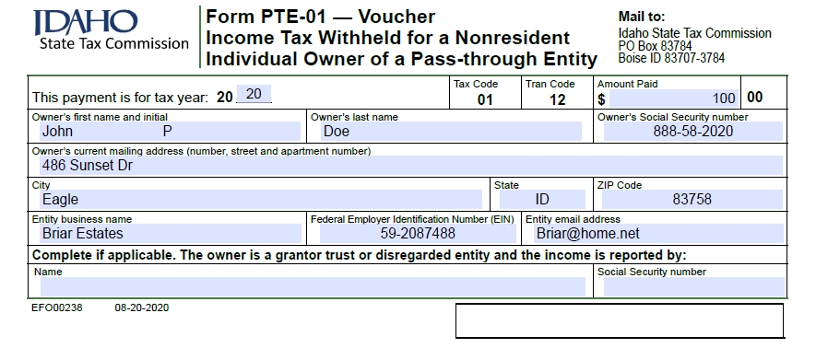

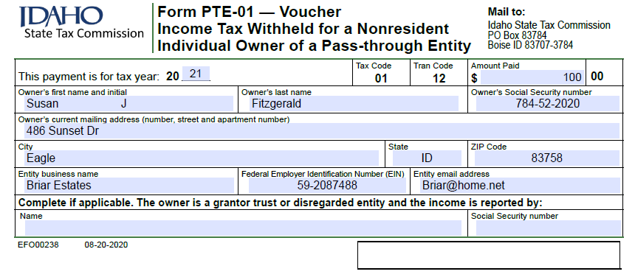

**ID FORM 51**

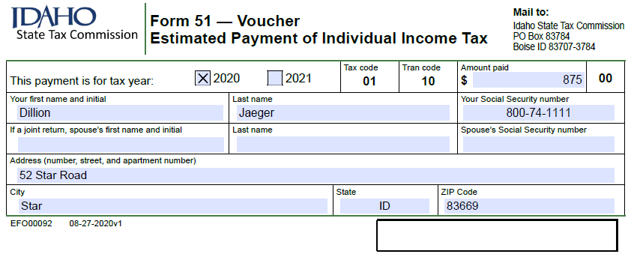

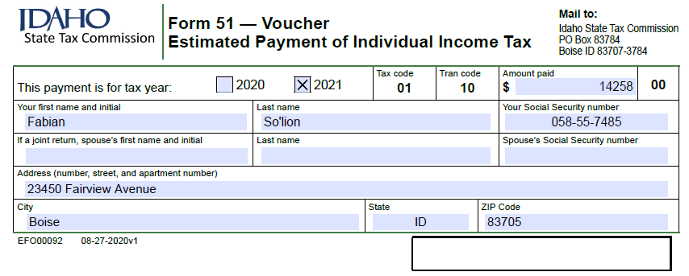

**ID FORM 41ES**

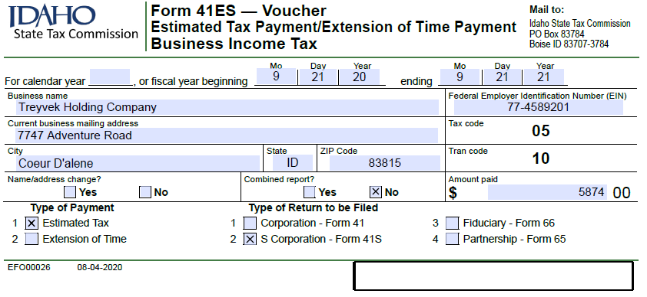

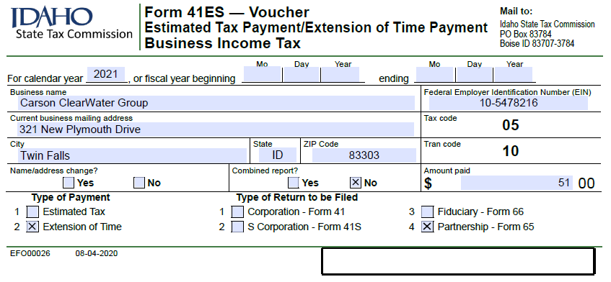

**ID FORM 850**

**Quarterly:**

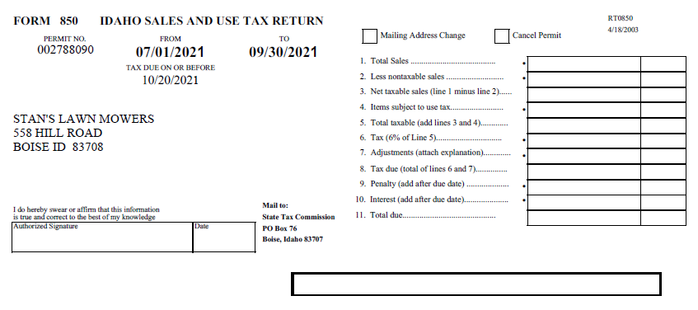

**Monthly:**

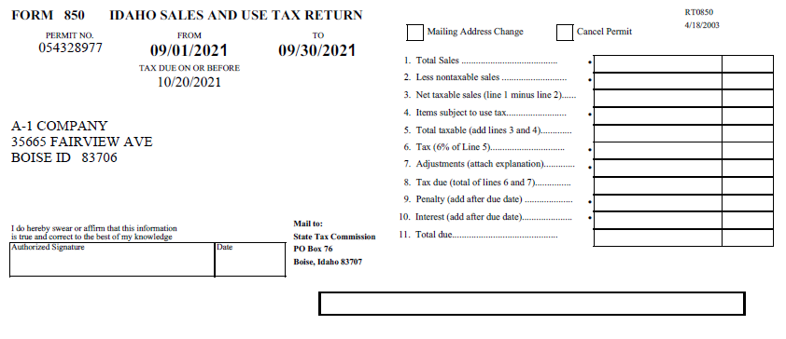

**ID FORM 910**

**Monthly:**

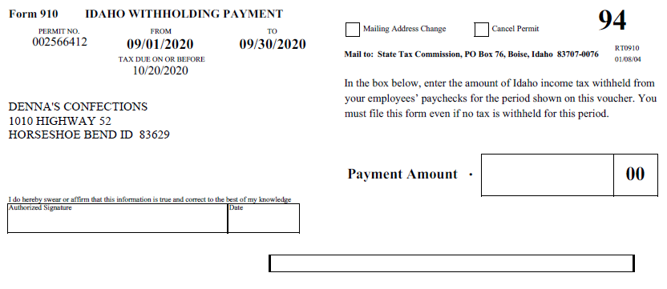

**Quarterly:**

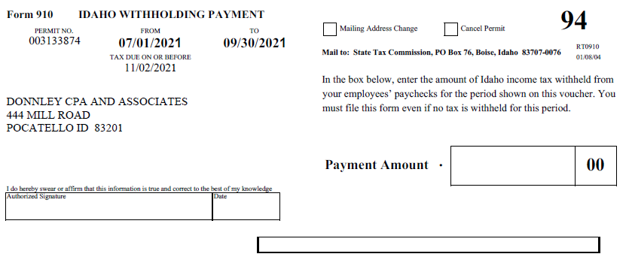

**ID Form 967**

**Monthly:**

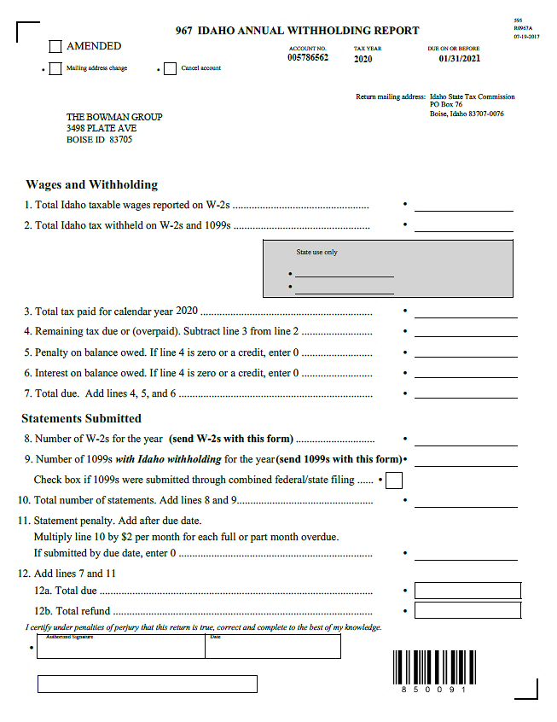

**Quarterly:**

