Updates to CIFT-620 Specifications

**1/14/2021**

The 2D Fields were renumbered to correct the issue of two 221 fields.

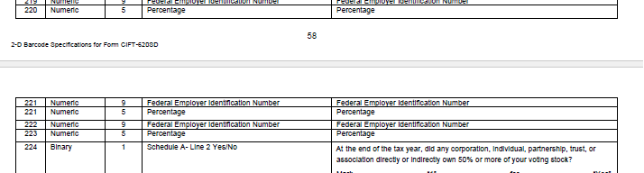

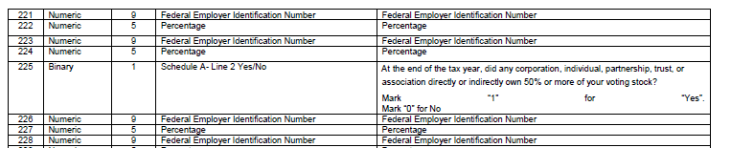

**1/19/2021**

Page 8- Added Line 11 to Franchise Tax

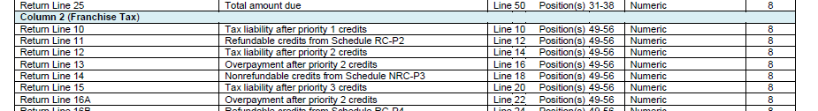

Page 8- Added Line 11 to Franchise Tax

