Updates between Versions of the Specifications for the 2D IT-540 return

**12/14/2020**

* Added Taxpayer’s Telephone Number field in the field placement and 2D barcode (field 24)

**12/15/2020**

* P4 – Unit Type use postal abbreviations such as APT, STE, FL, RM
* P7 – Nonrefundable Priority 1 Credits - This should be line 6 on the schedule C.
* P9 – Return Line 22 – instructions state to subtract line 22 from line 19 – this should be line 21 minus line 19
* P9 – Return line 31 – instructions state add lines 26 – 31, per the web instructions this should be add lines 25-30, not 26-31.

**12/15/2020**

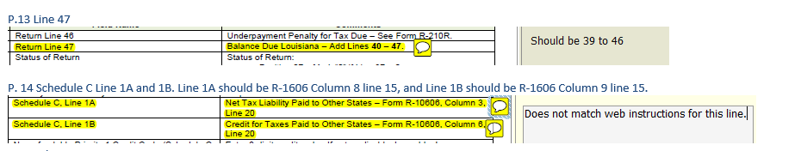

**Page 18**

Instructions were changed tocid:image016.png@01D6D2E5.B0F183D0

**Page 20**

cid:image020.png@01D6D2E6.95B5F7D0

**Page 30** –Field 43 changed to Field 45.

**Page 33**



**Page 35**

cid:image014.png@01D6D305.A433BE40

**Page 36**

cid:image016.png@01D6D305.A433BE40

**Page 13**



**12/28/2020**

**Page 19 and 36**

Added fields on Schedule E to include the retirement dates on Schedule E. The changes are highlighted on the specifications.

