**Changes Made to the 2D CIFT-620 Specifications**

**10/4/2023-** Corrected the field numbers for Schedule B. Field number 7 had been skipped by mistake.

Corrected Version:

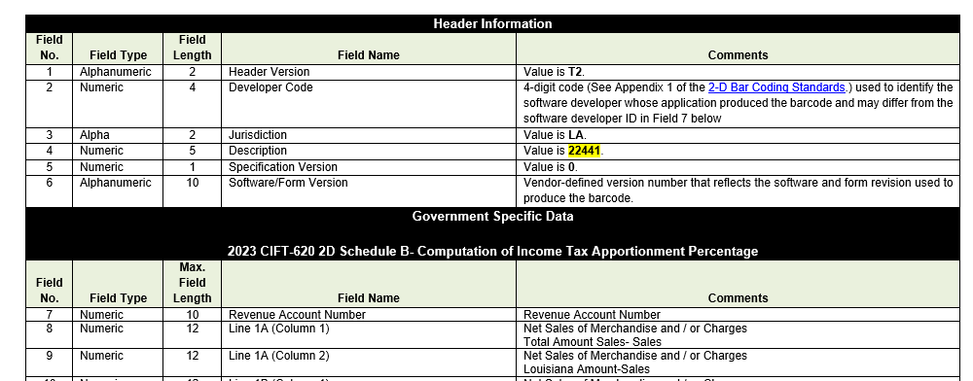

**10/16/2023**

Schedule N- The Descriptions were combined to make one data field for each line.

