Montana ATS Developer Update December 28, 2018

Many changes were performed this year for the Montana returns. We encourage you to thoroughly review the requirements documentation, and allow extra time for development and testing of the return.

For the first time, Montana has activated business rule automation. Please make sure your testing submissions can pass all business rule automation before submitting for testing. Software limitations should be documented with your test submission. If your software is still encountering reject codes because of limitations, reach out to [dore-services@mt.gov](mailto:dore-services@mt.gov) and we’ll help you work through the reject codes before your tests are submitted.

We are seeing some common problems developing the Montana Corporate return. Please note the reject code criteria for IRS schedule D and Form 5471.

**The criteria for this reject code (CIT-E260). Schedule D is required.**

Reject conditions and element tags

1)If line 2h on CIT is greater than zero**(MT Form)** and line 6, Federal Schedule D 1120 is zero. The xml element for this on the IRS Schedule D is

**UnusedCapitalLossCarryover**

**2)** If 3f on CIT is greater than zero **(MT Form**) and lines 7 and 15, Schedule D 1120 equal zero. The xml elements for these on the IRS schedule D are

**NetSTCapitalGainorLossAmt**(line7) and **NetLTCapitalGainOrLossAmt** (line 15)

**Criteria for reject code(CIT-230)-Schedule 5471 is required**

The reject criteria conditions are:

|  |  |  |  |
| --- | --- | --- | --- |
| Element Field | Criteria1 | Criteria2 | Error Code |
| IncLossWwideCombFiler | IncLossWwideCombFiler > 0 | fintform5471 = 0 | CIT-E230 |
| IncomeLossCorpTaxHaven | IncLossUnitaryCorp  > 0 | fintform5471 = 0 | CIT-E230 |

IRS element tags required are from IRS1120ScheduleN

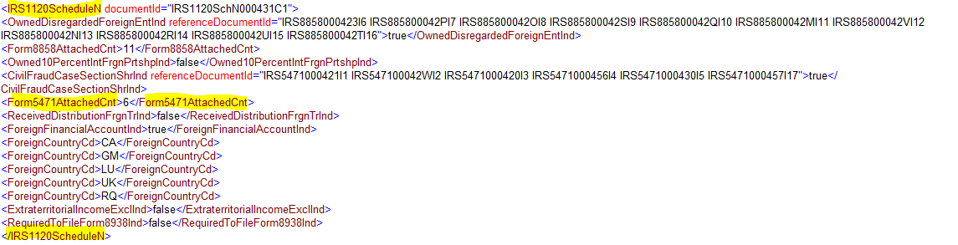

If you have additional questions and would like to schedule a time for a conference call, contact [dore-services@mt.gov](mailto:dore-services@mt.gov).

Thank you,

Tim

Tim Wilson, E-Services Program Manager

CSRM/Information Management

Montana Department of Revenue

(406) 444-9351