CAUTIONS

Global Variable $CUR (always shows cents 0.00) However, user is able to change settings below to Round Calculations which will then strip the cents to display dollars with no cents ( 0 ).

Allows user to change format in SuperForm under Document Settings.

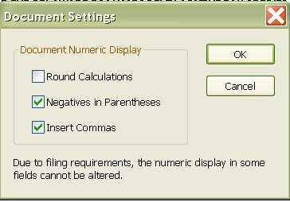

Hard-Coded .00 No caution statement is needed if hard-coded zeros are displayed on form, Forms Programming will know to change the global variable format from $CUR to ‘%0.0f’ to display dollars with no cents.

NOTE: If any of the Caution Statements below are added, Forms Programming must change the global variable format. User will NOT be able to Round Calculations.

Caution Statements:

Round amounts to the nearest whole dollar (enter as 100).
Format is '%0.0f' for money amounts.

Round amounts to the nearest whole dollar (enter as 100.00).
Format is '%0.2f' for money amounts. ( Use the (.round) on multiplication and division calcs only if they are money fields. )

Show amounts as dollars and cents (enter as 99.99).
Format is '%0.2f' for money amounts.

IMPORTANT: IF CAUTION IS ADDED, MODIFIED OR REMOVED…IT MUST GO BACK TO FORMS PROGRAMMING FOR REVIEW.

